EMail

David,

Thanks for this info! I looked through it all and, from my perspective, there is only one thing I would comment on, that being the checkout page. Visa has specific rules around subscription services and the disclosures they want to see on the checkout page. Now, those rules are geared more towards negative option (trial) subscriptions, and it does not look like you guys are doing that. I would, however, suggest putting some of the language on the checkout page that Visa requires for negative option subscription merchants, even if you’re not doing those trials.

Here’s a screenshot of one of the PrivateRecords checkout pages showing the disclosures.
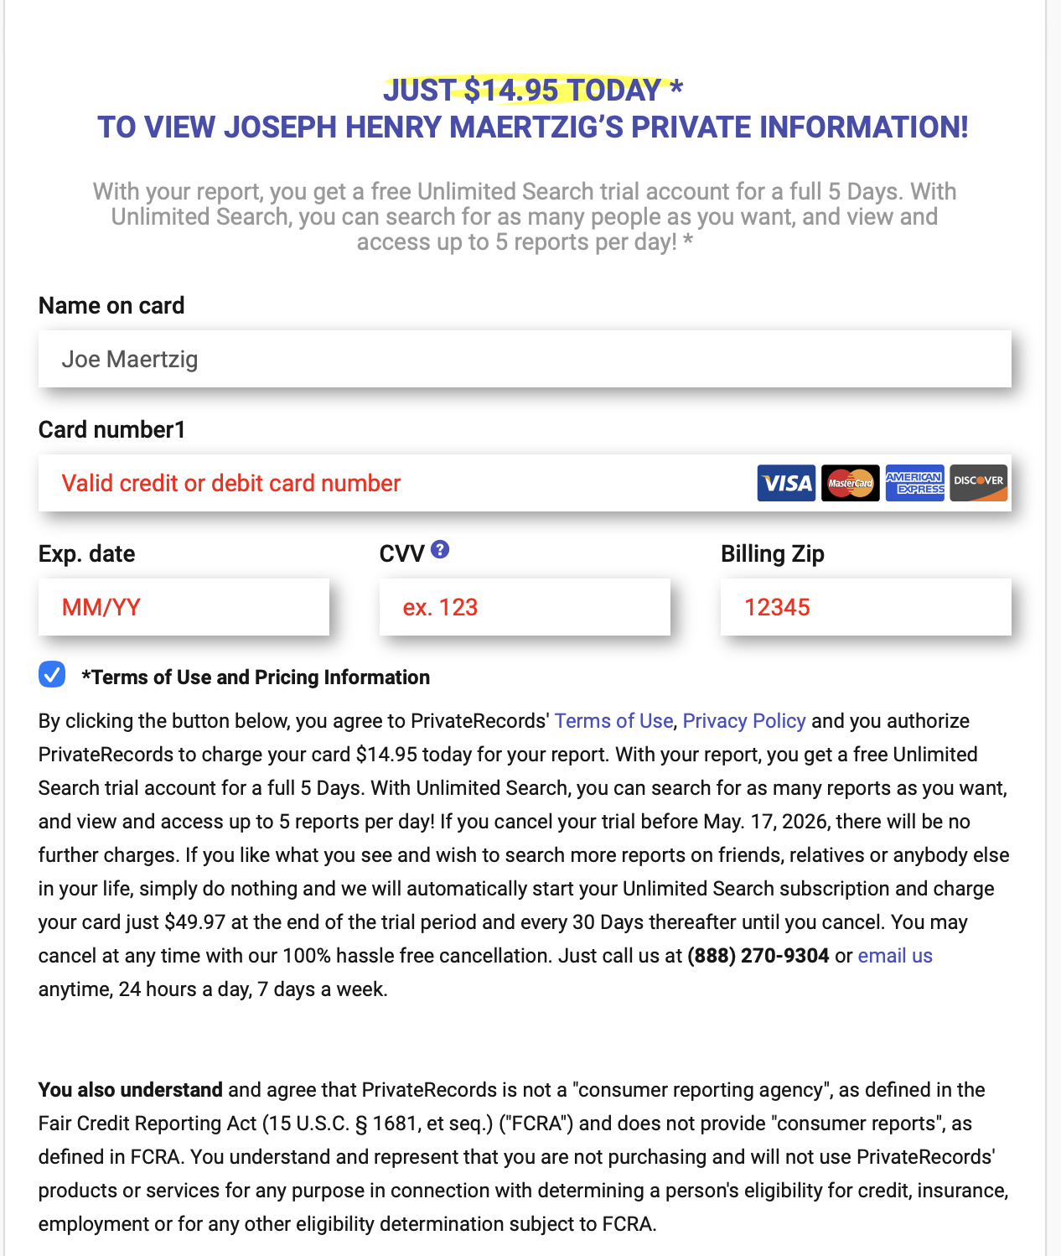

So, you guys do not have to explain that the trial lasts for 5 days then the merchant will be billed at the regular price starting at such and such a date, but I would describe the monthly subscription in a little more detail (i.e, by clicking submit, you agree to pay 29.95 today and your subscription will be renewed monthly until you cancel. You may cancel at anytime by calling, email or clicking this link). As a non-trial merchant, you are not required to have a button that the customer has to click (this is required for trial), but it’s not a bad idea. That is an affirmative agreement by the cardholder, so helps in risk mitigation, but, again, not required.

Also, be aware that Visa requires an email receipt upon initial purchase and and email sent to the customer at least 7 days prior to initiating the subscription rebill, so we’ll need to see examples of those when we go to apply for the merchant account.

I’m attaching the Visa rules around negative option subscriptions here. Again, since you are not doing a trial, you are not bound by all of these rules, but it’s a good indication of what Visa and the banks are looking for as far as subscription merchants are involved.

Let me know if you have any questions or would like to discuss in more detail.

Visa doc

OV E RV I EW
R EG I ST RAT I O N R EQ U I R E M E N T S OT H E R
N O N - C O M P L I A N C E
& R E M E D I AT I O N
F E E S &
A S S E S S M E N T S
3.3.3 Subscription “Negative Option” Merchants
Subscription or “Negative Option” Merchants offer free trials or introductory promotions that roll
into ongoing subscriptions or recurring charges.
Acquirers soliciting Subscription “Negative Option” Merchant activity must ensure the following
controls and provide the evidence of such controls to Visa upon request:
•
•
•
•
Express Consent: At the time of enrollment, Merchants must require the cardholder to
expressly consent to entering an ongoing subscription service for recurring payments.
Notification: At the time of enrollment, Merchants must send an electronic copy of the term
and conditions of the subscription service to the cardholder, even if no amount was due at
the time. This must include:
– Confirmation that the cardholder has agreed to a subscription
– Details of the goods/services
– Ongoing transaction amount and billing frequency / date
– Link of other simple mechanism to enable the cardholder to easily cancel any subsequent
transactions online
Merchants must also send an electronic reminder notification (i.e., email or SMS/text
message) and a link to online cancellation at least seven (7) days prior to initiating a
reoccurring transaction if:
– A trial period, introductory offer or promotional period has expired
– The nature of the recurring agreement has changes (for example: the price or
billing period)
Transaction Receipts: Merchants must disclose the following on transaction receipts:
– Length of the trial period, introductory offer or promotional period, including clear
disclosure that the cardholder will be charged unless the cardholder cancels any
subsequent transactions
– Transaction amount and date for the initial transaction (even if no amount is due) and for
subsequent recurring transactions
– A link or other simple mechanism to enable the cardholder to easily cancel online via
SMS/text message
Cancellation / Modification: Merchants must provide an easy way for cardholders to cancel the
subscription or payment online, regardless of how the cardholder initially interacted with the
Merchant. For example, the ease of the cancellation should be similar to “unsubscribing” from
an email distribution list.
© 2023 Visa. All rights reserved. Visa Confidential | 22

